**Contact Book Application**

**Contents**

1.Project definition and scope

1.1 definition

1.2 scope

2.Preliminary Design

2.1 Use case

2.2 Specifications of use cases

3.Data Dictionary

3.1 Table: category

3.2 Table: Contacts

4.Output Pictures

1. Project Definition and Scope

Definition:

A Book that lists the names, phone numbers of people and business in a certain area.

Scope:

1. Add Categories
2. Update Existing Categories
3. Delete Categories
4. Add New Contact
5. Delete existing contact
6. Update existing contact
7. Display All Categories
8. Display All Contacts
9. Display contact by contact id
10. Display contact by category id
11. Preliminary Design:

* This Contact Book application is using ASP.Net WEB API service to fetch and manipulate records of contacts in database.
* Database layer is developed for all the CRUD operations.
* Whole application follows n-tier architecture.
* All the forms are validated with client side validations with proper error messages.
* Database used in MS SQL Server.
* Following Fields are used for contact table.
  + Contact ID-------int
  + First Name-------varchar
  + Last Name--------varchar
  + Phone No---------varchar
  + Email---------------varchar
  1. Project Design (Use Cases diagram):

The use case diagram is usually referred to as behavior diagram used to describe the actions of all users in a system.

All users describe in use case are actors and the functionality as action of system

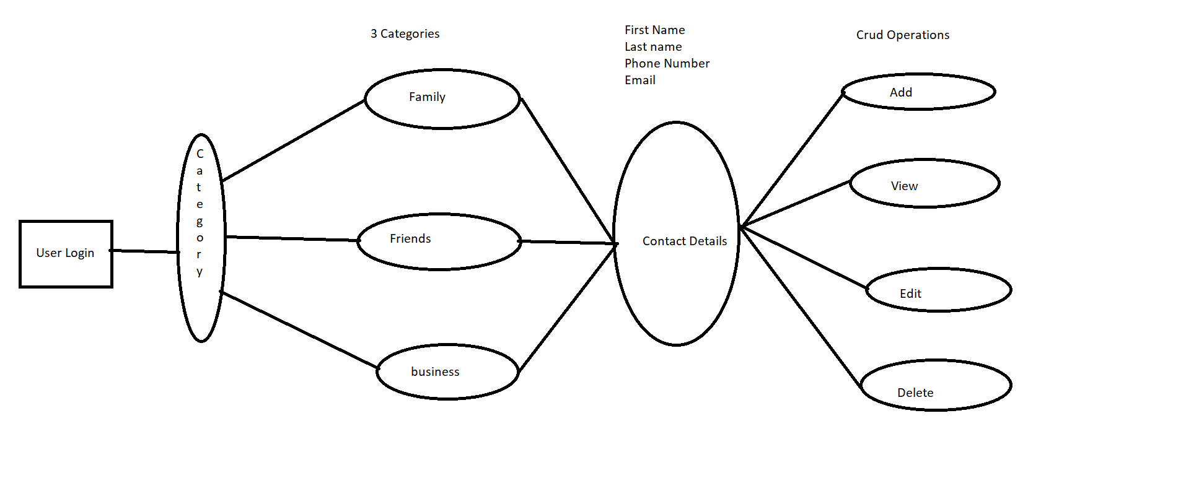

* 1. Specifications of Use Cases:

1. Use case : view Contacts

|  |  |
| --- | --- |
| Elements | Details |
| Person  Trigger  Pre-Conditions  Process | Admin  Admin Wants to view contacts  List of contacts will be displayed  1.Admin click login  2.Admin clicks view all contacts  3.List of contacts will be displayed |

1. Use Case : Add Contacts

|  |  |
| --- | --- |
| Elements | Details |
| Person  Trigger  Pre-Conditions  Process | Admin  New Contact Details to be added  New Contact form shown and Contact id generated Automatically  1.Admin click add new contact after login  2.Contact form displayed  3.Admin add the details in the form  4.Validation of all fields are to be done  5.Details has to be submitted to server  6.Message displayed as contact added. |

1. Use Case : Edit Contact

|  |  |
| --- | --- |
| Elements | Details |
| Person  Trigger  Pre-Conditions  Process | Admin  Edit of Contact after login  Edit contact shown, id should not be editable and editing details should be shown  1.Admin click edit contact beside contact  2.Edit Contact form details  3.Admin Edit the details  4.Validation of all fields are to be done  5.Details has to be submitted to server  6.Message displayed as Edited Contact saved. |

1. Use Case : Delete Contacts

|  |  |
| --- | --- |
| Elements | Details |
| Person  Trigger  Pre-Conditions  Process | Admin  Present Contact to be deleted  Present Contact should be deleted  1.Admin click Delete Contact after login  2.Contact should be deleted from data base.  3.Contact Deleted message should be shown. |

3. Data Dictionary:

3.1 Category Table:

|  |  |
| --- | --- |
| Field Name | Type |
| Categoryid | Int |
| Category_name | Varchar(50) |

3.2 Contact Table:

|  |  |
| --- | --- |
| Field Name | Type |
| Contact_id | Int |
| Category_id | Int |
| FirstName | Varchar |
| LastName | Varchar |
| Phone No | Varchar |
| Email | Varchar |

4. Output Pictures

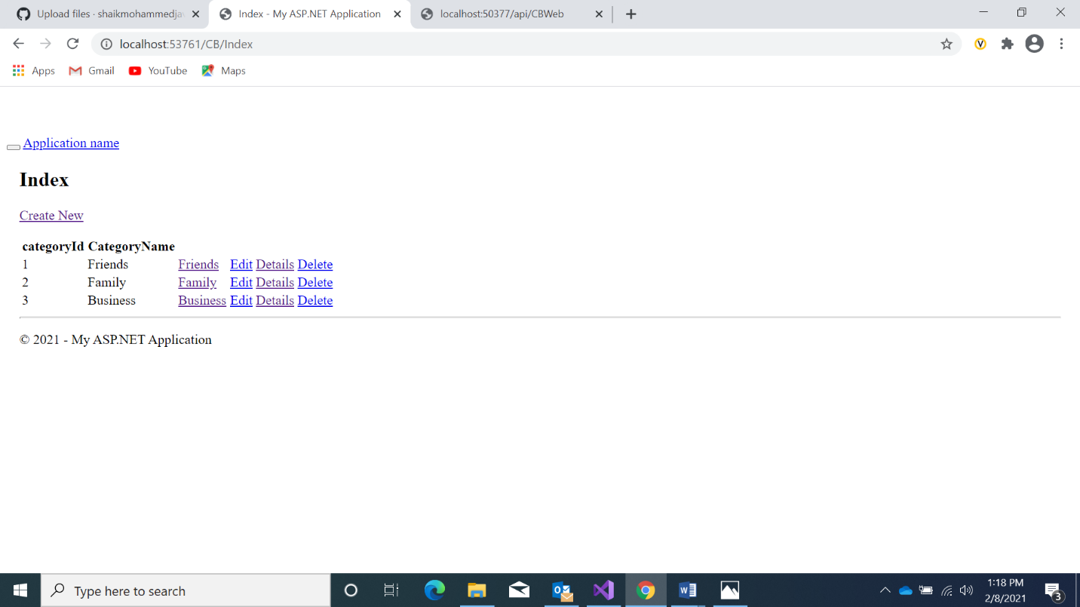

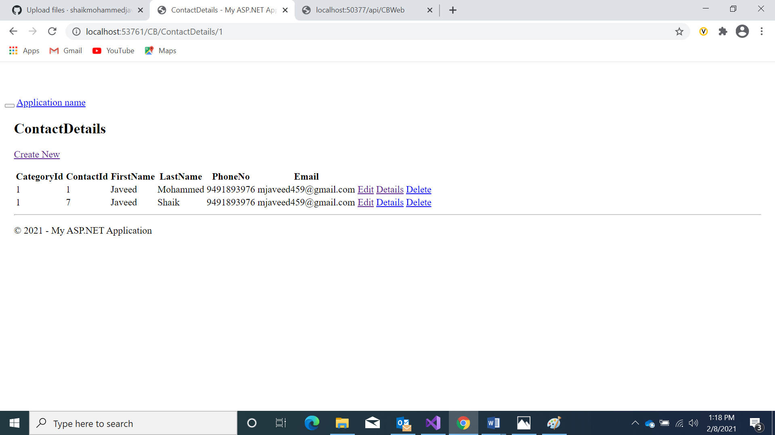

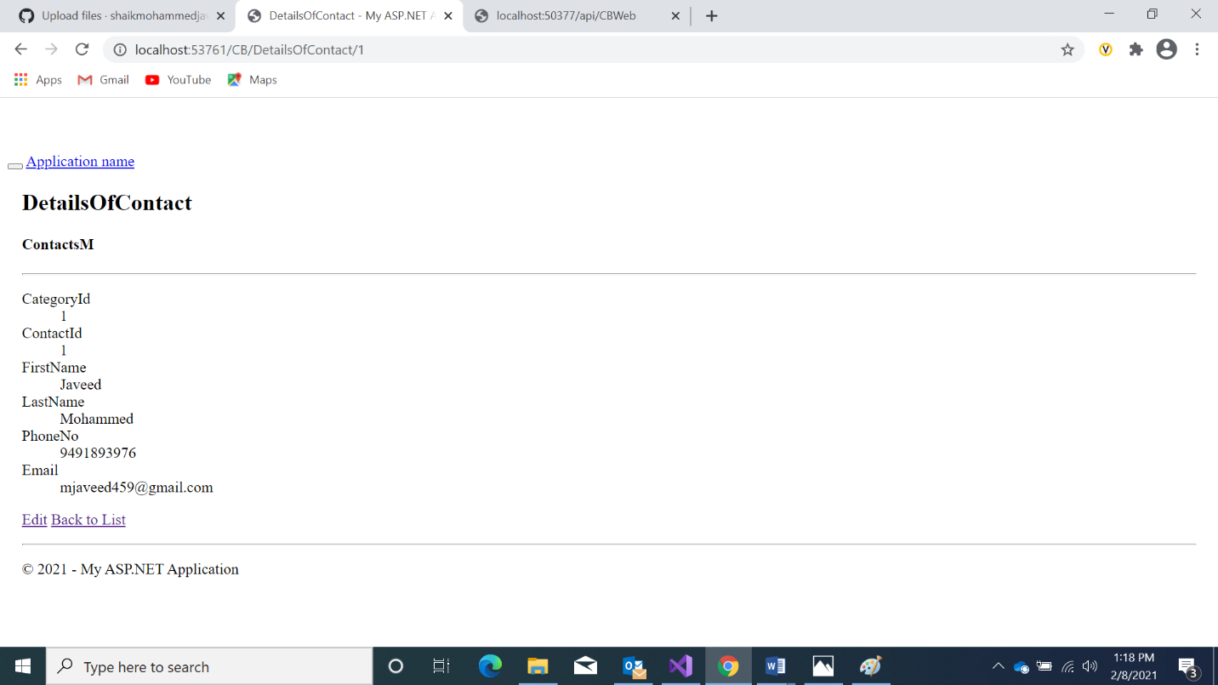

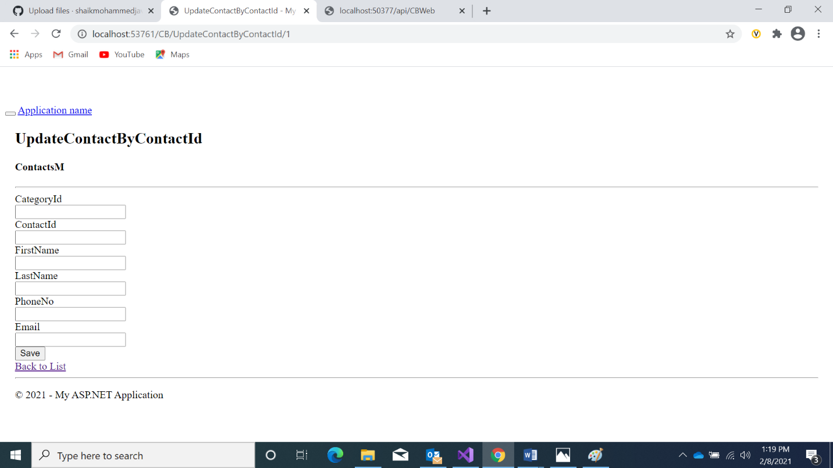

After delete contact operation

